Stay Focus– Work Breakdown Structure (WBS)
Level 1: 1.0 STAY FOCUC EXTINCTION

Level 2: Major Phases

  - System Analysis & Planning
  - System Design
  - AI Model Integration (Pre-trained Eye-Tracking Model)
  - System Development
  - System Testing & Validation
  - Deployment & Documentation
  - Project Closure

Level 3: Tasks under Each Phase

System Analysis & Planning

    - 1.1.1 Gather requirements (AI eye-tracking, extension behavior, user interactions)
    - 1.1.2 Identify hardware & software needs (camera access, browser compatibility)
    - 1.1.3 Define privacy & security constraints (local processing – no storage)
    - 1.1.4 Identify user flow and interaction logic
    - 1.1.5 Create project schedule and assign tasks

System Design

    - 1.2.1 Design user interface and user experience (UI/UX) for the extension
    - 1.2.2 Design system architecture (AI model → processing → extension UI)
    - 1.2.3 Prepare prototypes (popup UI, settings window, eye-tracking indicators)
    - 1.2.4 Review and approval of design

AI Model Integration

    - 1.3.1 Select pre-trained eye-tracking AI model
    - 1.3.2 Validate model performance and accuracy
    - 1.3.3 Prepare model conversion/optimization for browser use (Web-based runtime)
    - 1.3.4 Test model locally with sample inputs
    - 1.3.5 Ensure privacy (processing on-device, no data storage)

System Development

    - 1.4.1 Develop browser extension core logic (Chrome/Edge/Firefox)
    - 1.4.2 Implement AI eye-tracking pipeline inside the extension
    - 1.4.3 Implement UI components for popup/settings
    - 1.4.4 Implement performance optimizations (CPU/GPU usage)

System Testing & Validation

    - 1.5.1 Unit testing (AI model + extension features)
    - 1.5.2 Integration testing (AI + camera + extension logic)
    - 1.5.3 User testing (stability, responsiveness)
    - 1.5.4 Bug fixing and optimization

Deployment & Documentation

    - 1.6.1 Package and publish extension to Chrome Web Store
    - 1.6.2 Prepare user guide (how to enable camera, how to use features)
    - 1.6.3 Prepare technical documentation (AI model, pipeline, architecture)

Project Closure

    - 1.7.1 Final review meeting and approval
    - 1.7.2 Submit final documentation
    - 1.7.3 Handover to stakeholders

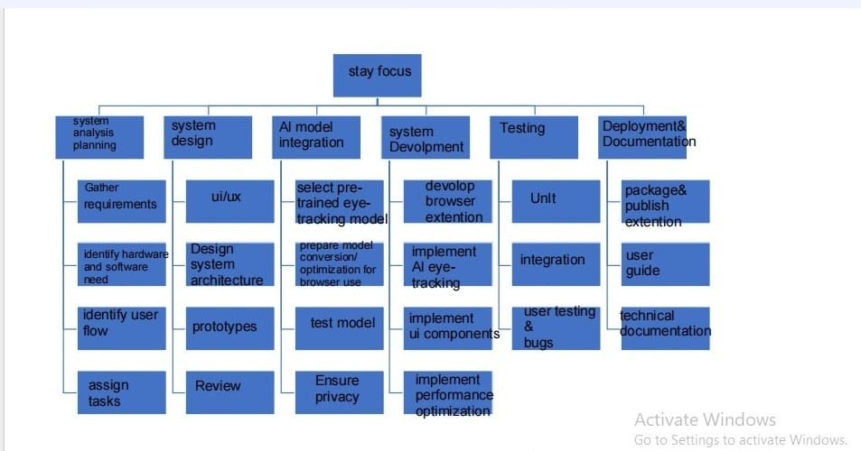

WBS DICTIONARY

Code Task Description Assigned People No. of
Resources
Budget (LE) Milestone (Date)

    - Gather requirements Ahmed Nasser (Analyst), Sarah
Fathy (Researcher)
2 1,000 05/03/2025

    - Identify hardware and software needs
Omar Khaled (System Analyst) 1 500 10/03/2025

1.1.4
Create a project schedule and assign tasks
Laila Mostafa (Project Manager) 1 700 15/03/2025 Hossam Magdy (UI/UX

    - Design UI/UX
Designer), Jana Ali (Graphic Assistant)
2 1,200 25/03/2025

    - Prepare prototypes Jana Ali (Designer), Youssef Kamal (Frontend Dev)
2 | 1,000 | 5/04/2025
2 | 500 | 5/04/2025
2 | 12000 | 15/04/2025
2 | 2,500 | 20/04/2025
2 | 2,000 | 25/04/2025

    - Review and approve design Laila Mostafa (PM), Ahmed Nasser
(Analyst)

    - AI Model Integration Alaa( Machine Learning Integration
Engineer )

    - Frontend development using Flutter
    - Backend development using SQLite
Youssef Kamal, Reem Tamer (Developers)
Mariam Said (DB Dev), Ali Hassan (Backend Dev)

    - Unit testing (individual functions) Rania Fathy (Tester), Ahmed 2 1,000 20/05/2025

Salah (QA Engineer)
    - Integration testing (SQLite) Ahmed Salah (QA), Youssef Kamal (Dev)
    - User acceptance testing Ministry of Health team (3 reviewers)

2 800 30/05/2025

3 700 5/06/2025

    - Bug fixing and optimization Developers team 2 1,000 15/06/2025

    - Deploy app to Android and iOS Ali Hassan (Dev), Laila
Mostafa (PM)
2 1,200 25/06/2025

    - Conduct user training Sarah Fathy (Trainer) 1 600 5/07/2025

    - Prepare user manuals and technical documentation
Mariam Said (Tech Writer), Jana Ali (Designer)
2 1,000 10/07/2025

1.6.1 Final review meeting and approval | Laila Mostafa (PM), Ministry of Health Rep. | 2 | 500 | 15/07/2025
1.6.2 Submit final report and documentation | PM + Team | 3 | 400 | 20/07/2025
1.6.3 Handover to Ministry of Health | PM + IT Admin | 2 | 600 | 25/7/2025

Responsibility Matrix

Laila
Ahmed
Sarah
Omar
Mariam Hossam
Jana
Youssef
Ali
Ahmed
Rania
MOH

WBS Code & Task
(PM)
(Analyst) (Researcher) (System
Analyst)
(DB
Dev)
(UI/UX) (Designer) (Frontend) (Backend)
S. (QA) (Tester) Team

Gather requirements
S | R | R | S | – | – | – | – | – | – – | – | –
S | R | – | R | – | – | – | – | – | – – | – | –
– | S | – | S | R | – | – | – | – | – – | – | –
R | S | – | – | – | – | – | – | – | – – | – | –
S | – | – | – | – | R | S | – | – | – – | – | –
– | – | – | S | R | – | – | – | – | – – | – | –
– | – | – | – | – | R | R | S | – | – – | – | –
R | S | – | – | S | – | – | – | – | – – | – | –
S | – | – | – | – | S | – | R | – | S – | – | –
– | – | – | – | R | – | – | – | R | – – | – | –
– | – | – | – | S | S | R | R | – | S – | – | –
– | – | – | – | S | – | – | – | R | – – | – | –
– | – | – | – | – | – | – | S | S | S R | R | –

Identify hardware & software needs
Define database schema (SQLite)
Create project schedule & assign tasks
Design UI/UX
Design database tables & relationships
Prepare prototypes
Review & approval of design
Frontend development (Flutter)
Backend development (SQLite)
Integrate text, images, and videos
Implement offline access feature
Unit testing (individual functions)

Laila
Ahmed
Sarah
Omar
Mariam Hossam
Jana
Youssef
Ali
Ahmed
Rania
MOH

WBS Code & Task
(PM)
(Analyst) (Researcher) (System
Analyst)
(DB
Dev)
(UI/UX) (Designer) (Frontend) (Backend)
S. (QA) (Tester) Team

Integration testing (+
– | – S | – – | S | S | – R | R | –
– | – – | – – | – | – | – S | – | R
– | – S | – – | R | R | S S | – | –
– | – S | – – | S | R | S – | – | –
R | – – | – – | – | – | – – | – | S
– | – R | – R | – | – | – – | – | –
– | – – | – – | – | – | – – | – | R
–  – – | – S  – – | – – | – | – | – – | – | –

SQLite) – –

User acceptance testing S –
(MOH approval)
Bug fixing &
optimization – –
app (Android/iOS) Deploy –
R
Conduct user training S –

Prepare manuals & documentation S –
Final review & approval R S
meeting

Submit final report & documentation R S
R – –

